**Chapter 4**

**Art and the Anti-Vietnam War Movement**

Artists, art groups and art collectives were active in the Anti-Vietnam War Movement. And art played an important role in the movement, and was an essential means of protest.The visual arts were especially effective tools for achieving the goal of informing the public about the atrocities being committed during the war and the human and social costs of the war. The use of images from the war by artists were powerful refutations of the claims of those in power. This chapter will exam the role of art and artists in the Anti-Vietnam war movement.

**Art in the Early 1960s**

In the early 1960s art had little to do with social issues, and when it did, it was rarely exhibited in museums. The reasons for this were varied but two of the most important were the still present shadow of McCarthyism[1] and the acceptance of an assumption that art existed in a dimension of its own, “high art” or what Herbert Marcuse called the “aesthetic dimension” (Marcuse) and the place for art was in museums, private galleries, and private collections (Lippard).

An exception to the rule was Wally Hendrick who was one of the first artists to criticize in his artwork United States’ policies in Vietnam. He did this in the late 1950s. As a Korean War veteran, Hendrick knew that war had devastating effects on countries and their cultures and he believed that U.S. involvement in Vietnam would have those effects on Vietnam. His 1959 painting titled *Anger/Madam Nhu’s Bar-B-Q* (Figure 5). The painting’s text read, “Madam Nhu Blows Chiang” and “Anger.”

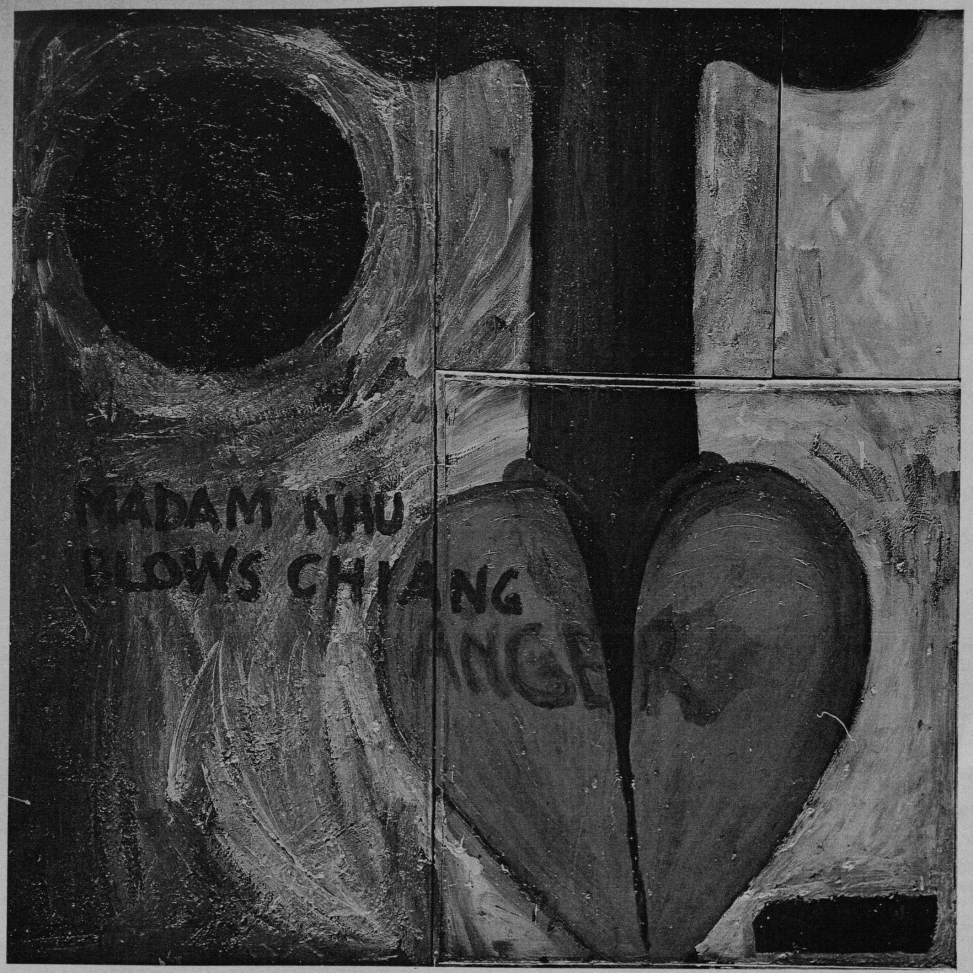

Madam Nhu was the sister-in-law of Diem and widely accepted as the first lady of South Vietnam. She was a devoted Catholic who became a symbolic figure of repression towards Buddhist monks. She wrote a letter to the *New York Times* saying, "I would clap hands at seeing another monk barbecue show, for one cannot be responsible for the madness of others” (Karnow 1997:210). The painting depicts a black sun with a brown penis inserted into a red heart and a mushroom cloud in the background. The painting criticizes U.S. policy in Vietnam. It depicts the policy has both an attack on the “heart” of Vietnamese culture, Buddhism, and high tech violence directed at the Vietnamese people.[2]

Activism within the art community started to emerge in 1965 as art collectives such as the New York based art group called the Artists and Writers Protest (AWP). The AWP was one of the first art collectives to urge the art community in New York City to protest the escalation of the war. In the spring of 1965[3], following the deployment of Marines in Da Nang, AWP placed two letters, “End Your Silence,” in the *New York Times*. These letters advocated the withdrawal of U.S. troops from Vietnam.[4] Many well-known artists such as Rudolf Baranik, Leon Golub, Nancy Spero, and May Stevens signed the letters. In another letter, June 1965, AWP stated, “American artists wish once more to have faith in the United States of America. We will not remain silent in the face of our country’s shame” (Shafer 1990:268).[5]

Simultaneously, on June 26, 1965, the Artists and Protest Committee (APC), based in Los Angeles, picketed the Rand Corporation, a government think tank, to protest their involvement in U.S. interventions in Vietnam and the Dominican Republic. Other grassroots art organizations began to emerge after 1966. And by 1966, art and artists were coming out of the galleries and the museums and into the streets, and the art that was emerging was becoming an essential tool in the Anti-Vietnam War movement (Bradley, Lippard and Martin).

**Art Collectives**

In 1966, AWP organized the construction of the *Peace Tower* (Figure 6) to protest against the escalation of the war in Vietnam. The sixty-foot tower[6] covered with 400 uniformly sized panels sent by antiwar artists all over the world was raised on a rented vacant lot located on the corner of Sunset and La Cienega Boulevards, a highly visible intersection, in downtown Los Angeles. Advertised in the *New York Times* and attended by many well-known antiwar activists such as Irving Petlin, Susan Sontag, and ex-Green Beret Donald Duncan. Duncan, who spoke on the opening day said, “I am not here today to protest our boys in Vietnam, I’m here to protest our boys being in Vietnam” (Bryan-Wilson: 2009:11). In New York City, the same week as of the opening of the *Peace Tower*, AWP organized a weeklong event called, “Angry Arts Against the War in Vietnam” (Figure 7). During the week, there were a series of dances, music, film, art, poetry, and photography events. Over six hundred artists participated in the events. A 10-foot-by-120-foot canvas with 150 panels called *The Collage of Indignation* (Figure 8), was also created and exhibited during the week (Lippard).[7]

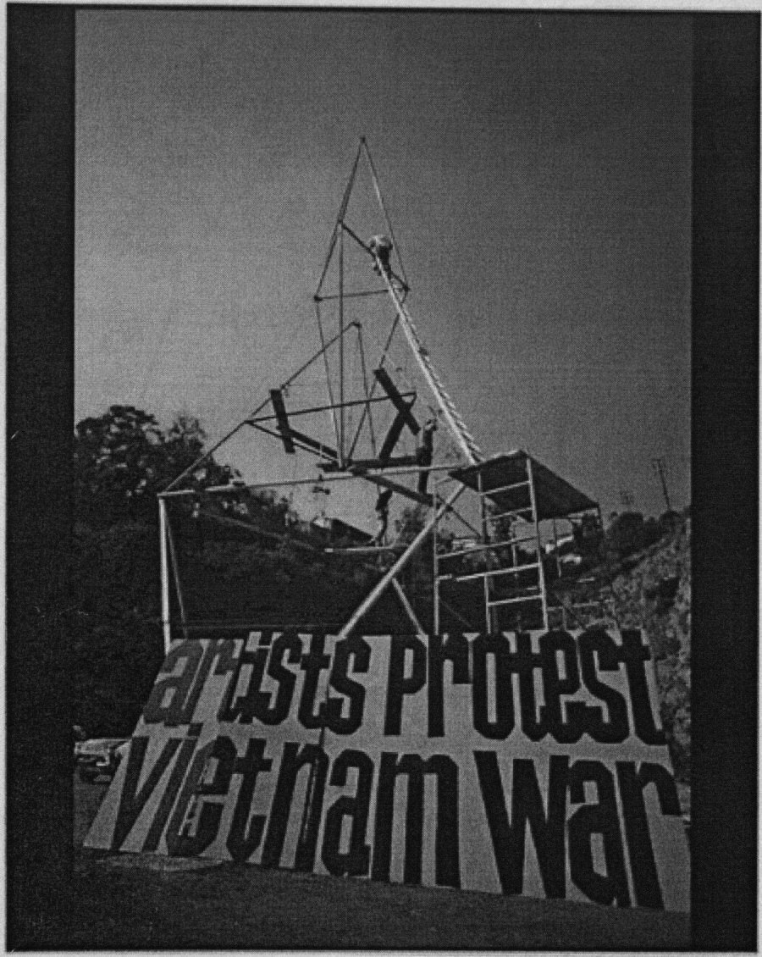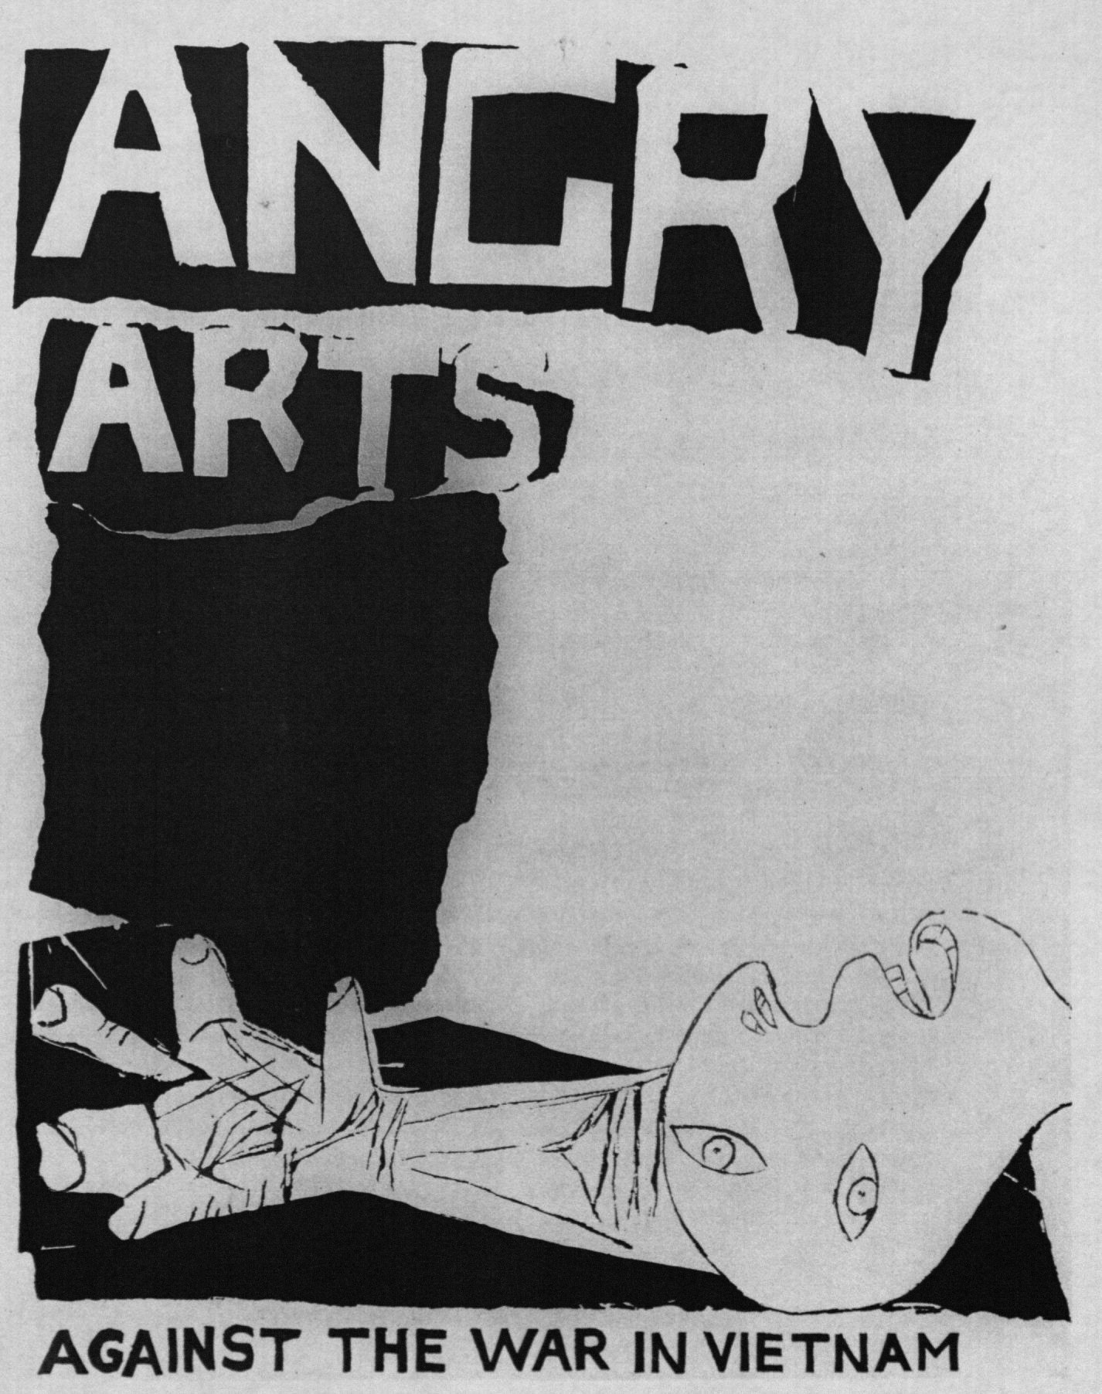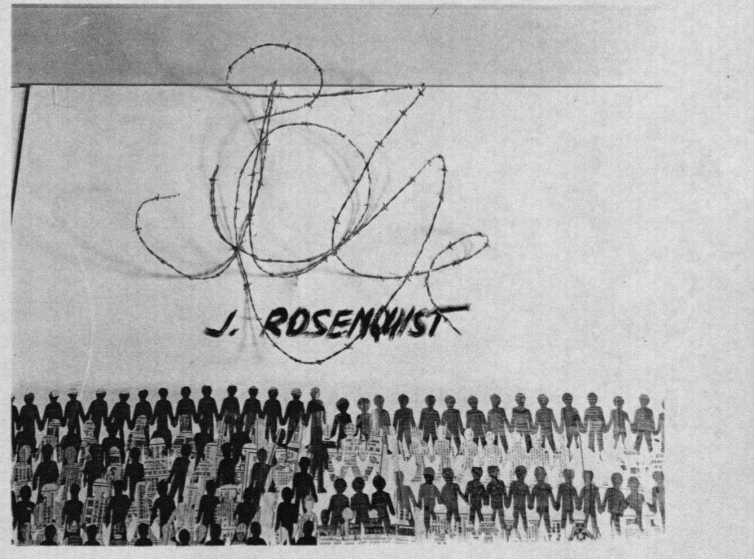

In 1967 Ad Reinhardt created *No War* (Figure 9) for the Artists and Writers Protest portfolio. It was a double-sided postcard addressed to the “War Chief, Washington, D.C., USA.” In Gothic script it reads:

No war, No imperialism, No murder, No bombing...No consciencelessness.

No Art of War, No Art by War, No Art to War, No Art on War, No Art by War, No Art from War, No Art about War, No Art for War, No Art with War, No Art of War (Lippard).

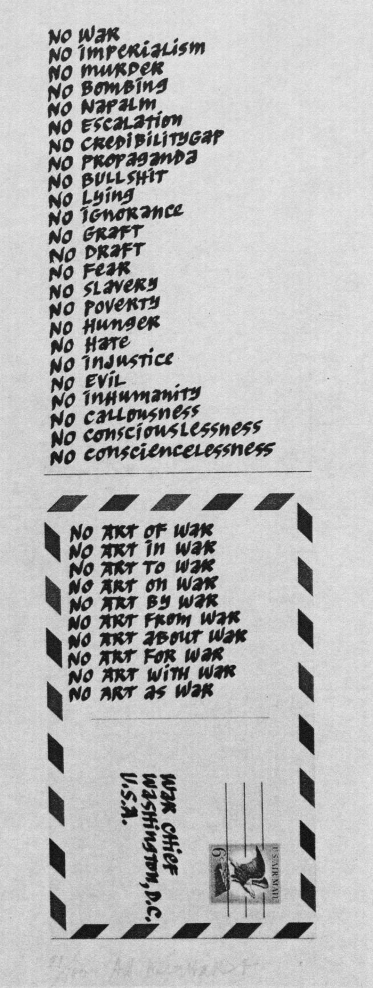

Artists became more involved in the anti-war movement after the Tet Offensive and revelations of the My Lai Massacre. The Art Workers Coalition[8] (AWC) and the Guerrilla Art Action Group (GAAG) were established in 1969. Both groups organized series of antiwar protests in New York City. These groups engaged in more radical types of protest. Examples of these protests were Guerilla Theater[9], agit-prop exhibitions, and sit-ins at New York museums (Lippard). And these protests came to be known as “events” or “happenings.”

On April 2, 1969, in response to the Tet Offensive, AWC organized an event called the “Mass Antiwar Mail-In.” The event consisted of antiwar artwork which was addressed to “The Joint Chiefs of War.” The protesters marched to the Canal Street Post Office and mailed the art work to Washington, D.C. All of the work was accepted and mailed. One month later, members of AWC and AWP carried black body bags, identical to those used to return dead American soldiers from Vietnam. The protesters walked along a white cloth runner inscribed with the names of the dead (Martin).

The GAAG engaged in more radical protests and connected the art world, the aesthetic dimension, to the war.[10] In a list of demands sent to the Museum of Modern Art, they said “There is no justification for the enjoyment of art while we are involved in the mass murder of people…today the museum serves not so much as an enlightening educational experience, as it does a diversion from the realities of war and crisis” (Lippard 1990:40). Further, they linked the art world to the military industrial-complex. The group pointed out to the public that David Rockefeller, Chairman of the Museum of Modern Art board, was tied to the Defense Industry Advisory Council, and held controlling interest in Standard Oil which was tied to Dow and McDonnell Douglas corporations.[11] After receiving no response, the GAGG performed “Blood Baths” in major museums (Figures 10 and 11). As the protesters entered the museums, they threw a list of demands on the floor and ripped at each other’s clothes while crying “Rape!” They had concealed sacks of animal blood which they opened and poured out. After the dramatic performance, the audience applauded and GAAG members asked the audience to “help us clean up the mess” in Vietnam (Bradley, Lippard and Martin).

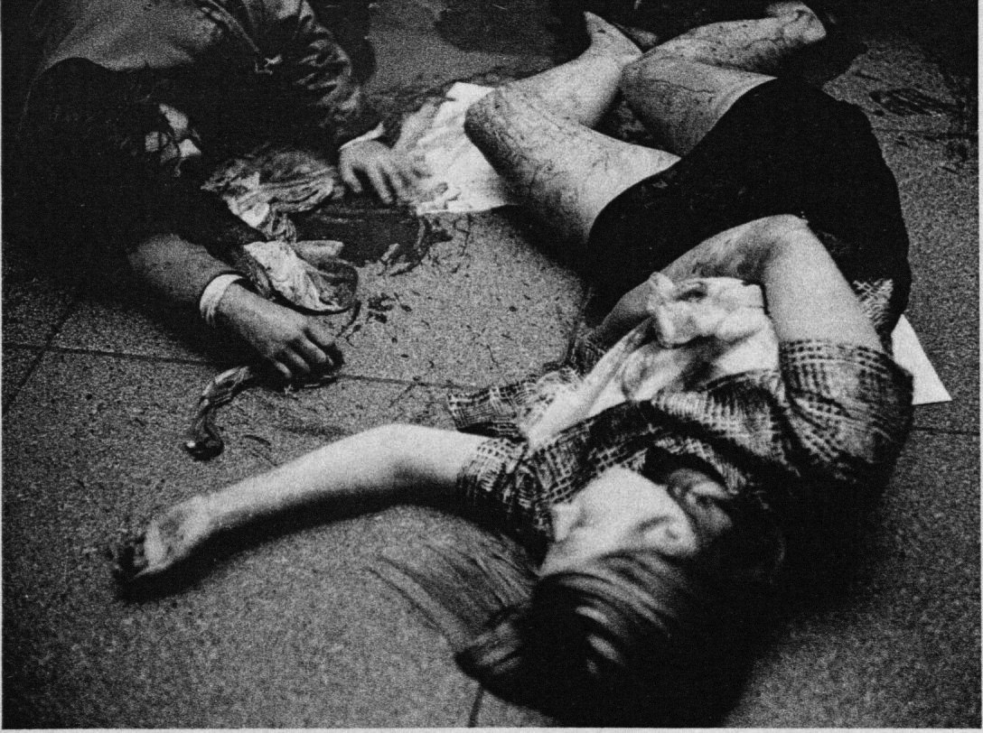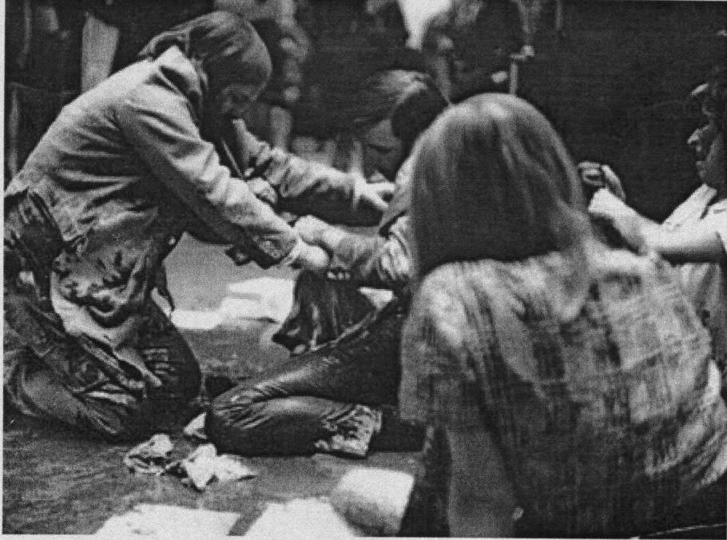

On May 18, 1970, following the invasion of Cambodia and the subsequent shooting of student demonstrators at Kent State and Jackson State, artists organized Art Strike. Approximately, fifteen hundred artists met at New York University’s Loeb Student Center and planned Art Strike. Officially calling the strike, “The New York Artists’ Strike Against Racism, Sexism, and Repression,” the artists sent telegrams to the city’s museums and galleries asking them to close on May 22. The goal of Art Strike was to not only address the art world’s complicity in the war, but it also wanted to transform the art world itself, to open it to greater representation of women and artists of color. The Whitney Museum, the Jewish Museum, and fifty private galleries closed in New York City. The Metropolitan Museum of Art stayed open, and in response, over five hundred artists participated by blocking the museum entrance for twelve hours. The protest gained extensive local television coverage. Yet artists knew that they had to go beyond the formal art world and many artists and art organizations started to produce posters and flyers in order to reach a mass audience. Political posters became one of the most effective tools of protest during the Anti-Vietnam War Movement. Between 1965 and 1973, an estimated 20,000 to 40,000 anti-Vietnam War posters were produced (Tucker).

**Political Posters**

The themes of many of the posters reflected the tactics used by the protesters during the antiwar movement. As mentioned in Chapter Three, draft resistance was one of the most prominent tactics. For example, one such poster (Figure 12) shows Joan Baez posing with her sisters, Pauline and Mimi. The poster encourages draft age men to say “no” to the draft. The poster reads, “*Girls Say Yes to boys who say NO*.

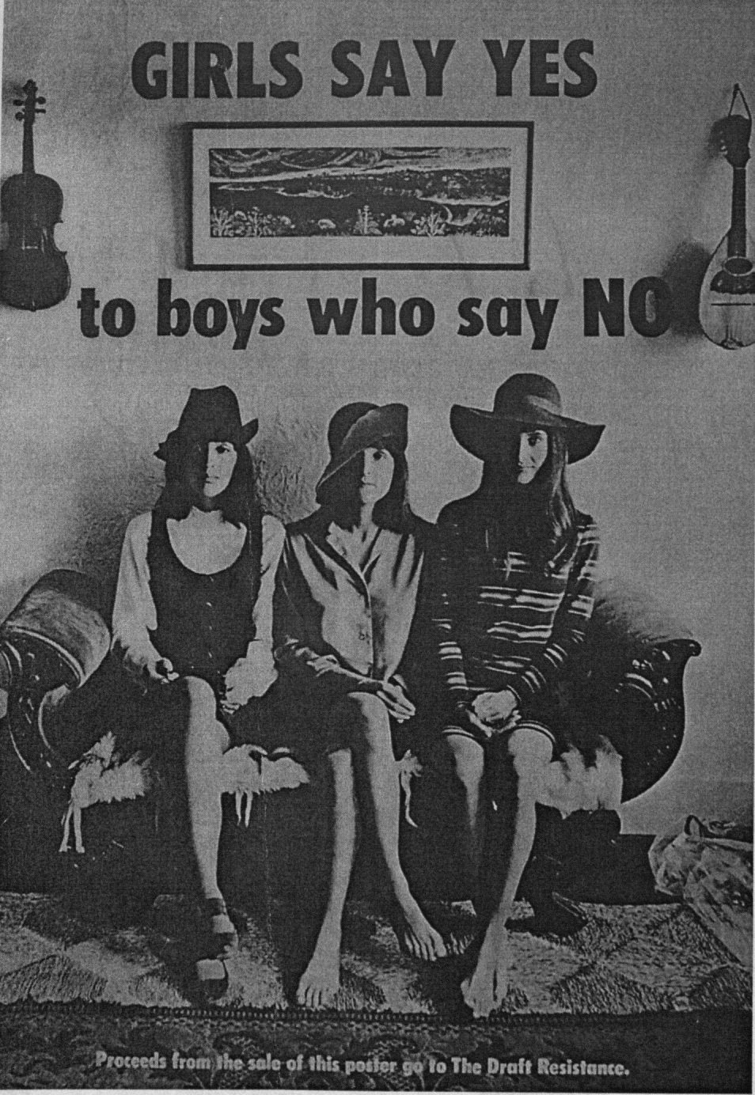

Burning draft cards was a public declaration of one’s refusal of the draft. FUCK THE DRAFT (Figure 13) is a political poster, created by a group called Dirty Linen Corporation, that is a photo of a male burning his draft card and reads: FUCK THE Draft.

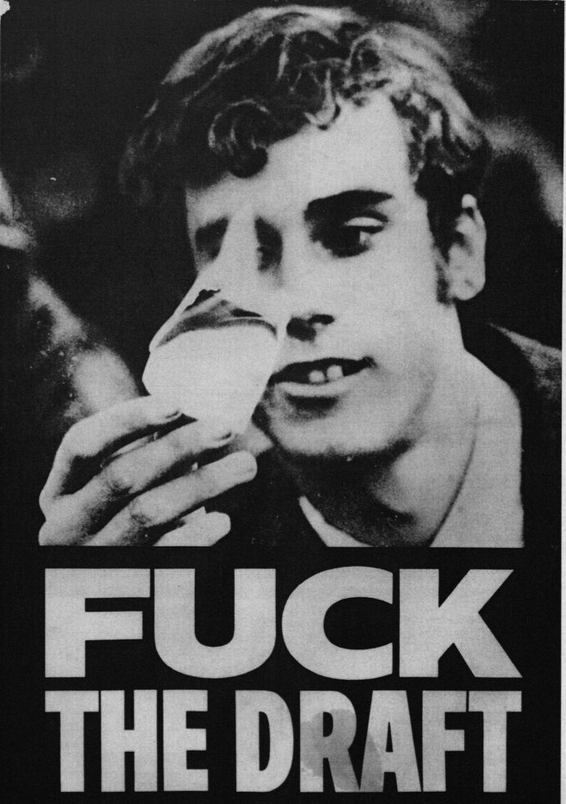

Another poster *Don’t Register for War* (Figure 14) is a black and white drawing of General William Westmoreland as a chicken. He is wearing medals from corporations of the major weapons manufactures, Boeing, Raytheon, DOW, TRW. In the background of the poster, dead American soldiers wrapped in American flags are being disposed.

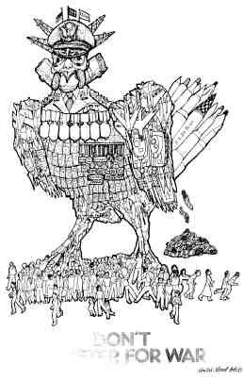

The most significant political poster to emerge from artists during the anti-war movement was titled *Q: And babies. A: And babies* (Figure 15). The artists, who chose to remain anonymous, used Ronald Haeberle’s color photograph of civilian victims, women, children and elderly, of the My Lai massacre. A quote overlay the photo; it was a quote from Mike Wallace’s interview with an American soldier, Paul Meadlo, who had participated in the My Lai massacre. Mike Wallace asked, “Did you kill civilians”? And Meadlo replied, “Yes.” And then Wallace asked, “And babies?” And Meadlo replied, “And babies.” The poster was an anonymous collaboration[12] and originally intended to be shown at the Museum of Modern Art, however it became much more. The Museum refused to show the work and in doing so made it even more popular. Protests by artists followed. Jon Hendricks and Jean Toche (Figure 16) are holding *Q: And Babies? A: And Babies* in front of Picasso’s *Guernica*. *Guernica* is a painting that depicts the bombing of the Spanish town of Guernica on April 26, 1937.[13] The demonstrations received world-wide publicity and resulted in the creation of fifty thousand copies of the poster. The poster became ubiquitous at anti-war rallies, marches, and demonstrations.

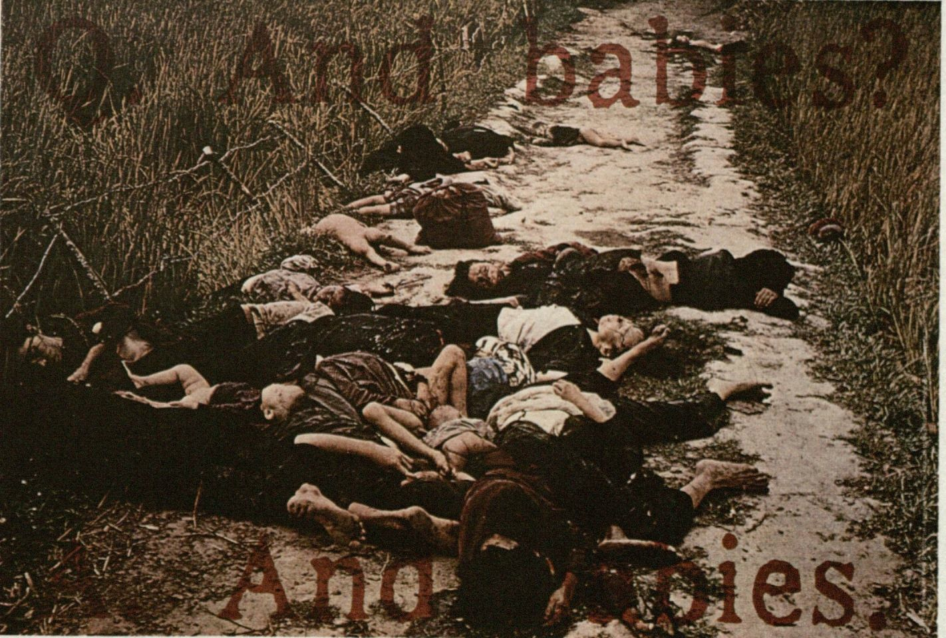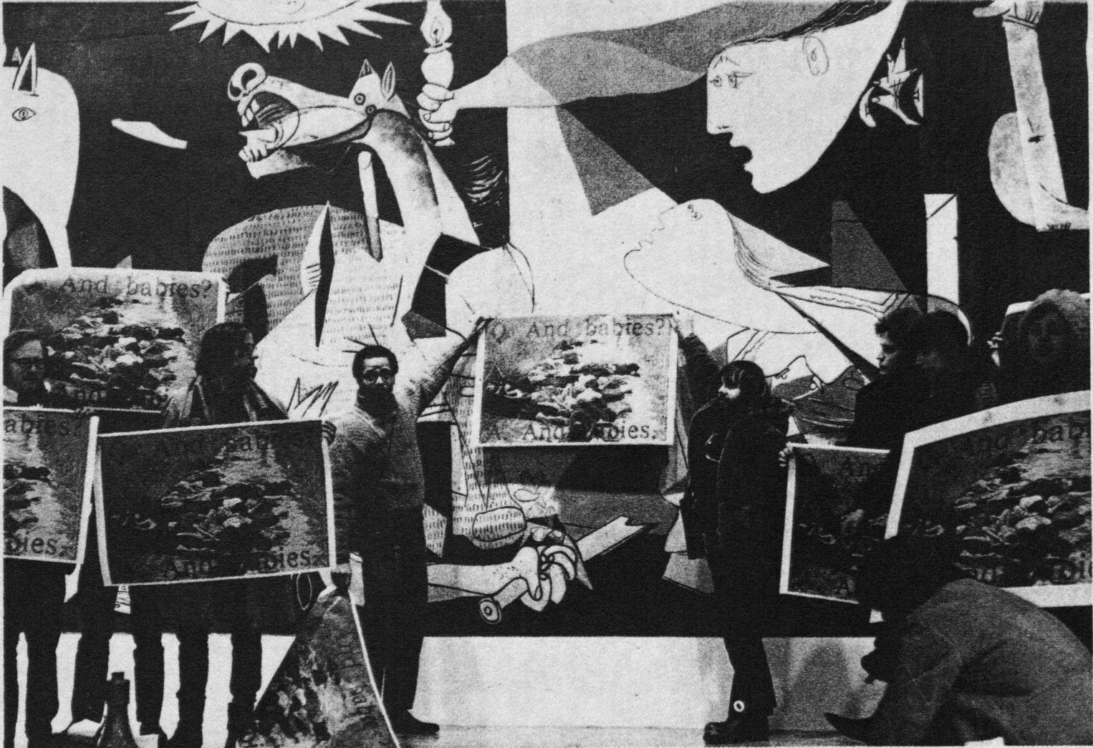

Many artists created posters as a means to inform people about planned protests and demonstrations. Borrowing the name from Freedom Summer of 1964, antiwar activists organized Vietnam Summer in 1967.[14] A poster, *Vietnam Summer,* (Figure 17) was created to inform people of Vietnam Summer and depicts a fleeing Vietnamese women who is carrying two babies, one upside down and disfigured. The woman and babies are painted in red behind a yellow background. *End Demonstrations. End the War, (*Figure 18) is another example of a poster whose goal was to inform people of a demonstration in New York City. The poster depicts four individuals holding protest signs. A young woman is holding a poster of a injured Vietnamese child while a woman to her right is holding a poster with a peace sign and wearing a button that reads, “Peace in Vietnam.” A black man holds a poster that says “No Viet Cong Ever Called Me Nigger”[15] and in the background there is a man holding a poster that says, “Stop the War.”

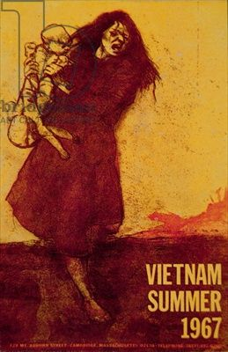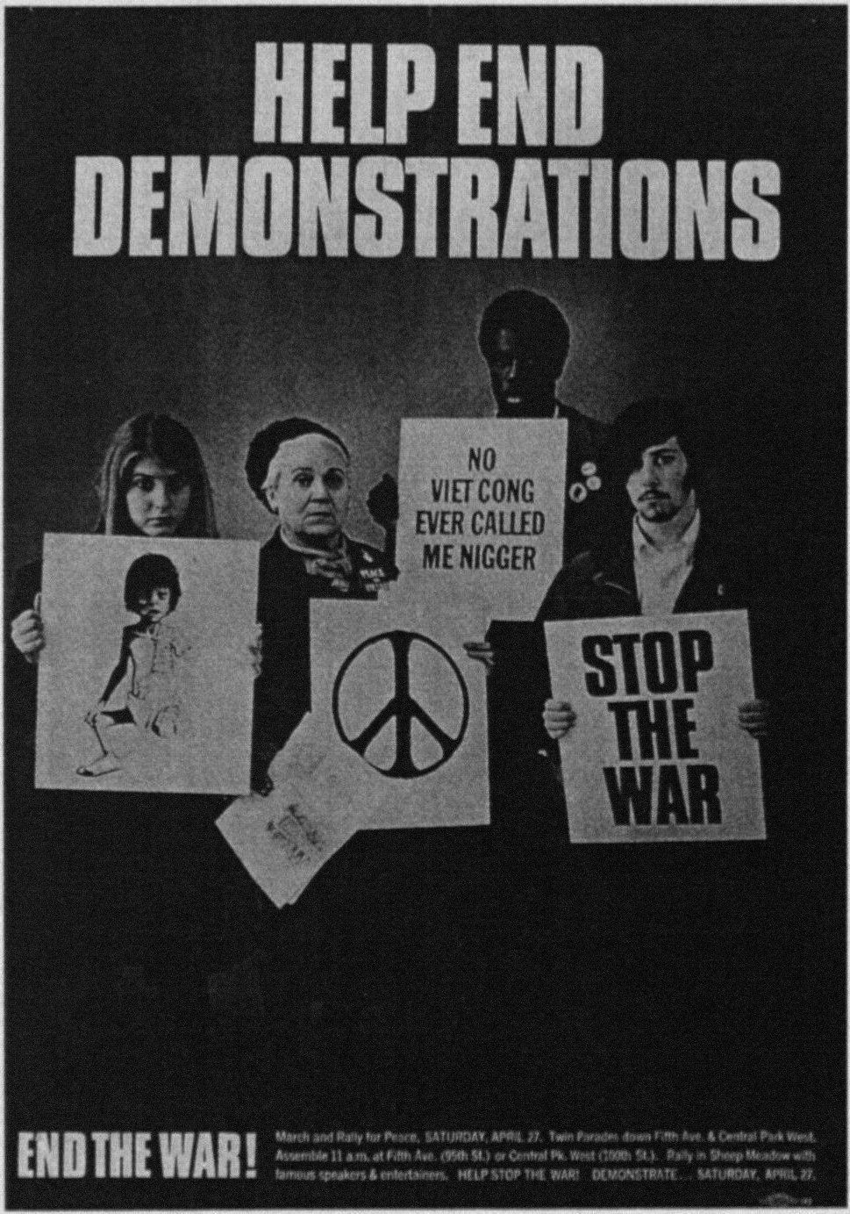

Artists produced artwork for the National Vietnam Moratorium on October 15, 1969. The main focal point was in Washington, D.C where 250,000 people demanded that the Nixon Administration end the war. As mentioned in the previous chapter, two million Americans across the nation participated in the Moratorium. Jasper John was commissioned to create a poster (Figure 19) for the Moratorium. It is a depiction of the American Flag, but not red, white, and blue colors. The flag has black stars and stripes on an orange background. There is a white whole the size of a bullet in the middle of the flag. According to Lippard, the white whole refers to a poem by Yevgeny Yevtushenko: “The Stars/ in your flag America/are like bullet holes” (Lippard 1990:56).

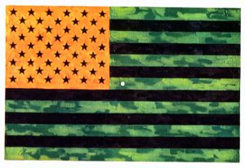

Many others artists also continued to use the American flag as a symbol of protest despite the fact that the Flag Desecration Bill had been passed in 1967. The use of flags in antiwar artwork had been determined to be desecration after the case of Marc Morrel, an ex-Marine. Morrel’s one-man show (Figure 20) had resulted in his arrest and conviction and the arrest and conviction of his dealer, Stephen Radich. The case resulted in the passage of Federal Flag Desecration Bill in June 1967. Artists known as the Judson Three challenged the flag desecration law by organizing a week-long art show called “The People’s Flag Show[16]” The group argued, “a flag which does not belong to the people to do as they see fit should be burned and forgotten…if the flag can be used to sanctify killing, it should be available to the people to stop killing” (Lippard 1990:70). The Judson Three were arrested, tried, and convicted, despite legal defense by the ACLU and protests in Europe as well as in the U.S.[17]

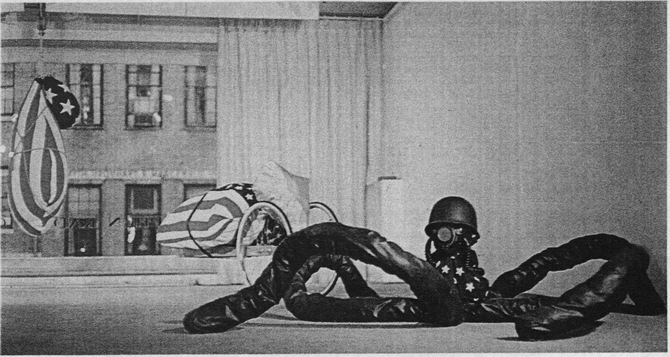

Icons of American culture and consumer products were also used in anti-war posters as symbols of violence and oppression. Antiwar posters used not only the American flag, but the Statue of Liberty, Uncle Sam, and Coca-Cola (Figure 21). One such poster, produced in 1971, shows a tilted Coca Cola bottle to represent Napalm. The poster reads, “It’s the Real Thing for S.E. Asia” and in smaller print below the bottle reads, “Trade-Mark United States” all rights reserved. A poster (Figure 22) by Violet Ray shows two terrified Vietnamese women and children struggling to cross a river. On the left half of the poster is a nude model in a river to advertise Chanel. The words on top of the poster read, “This is the Spell of Chanel for the Bath.”

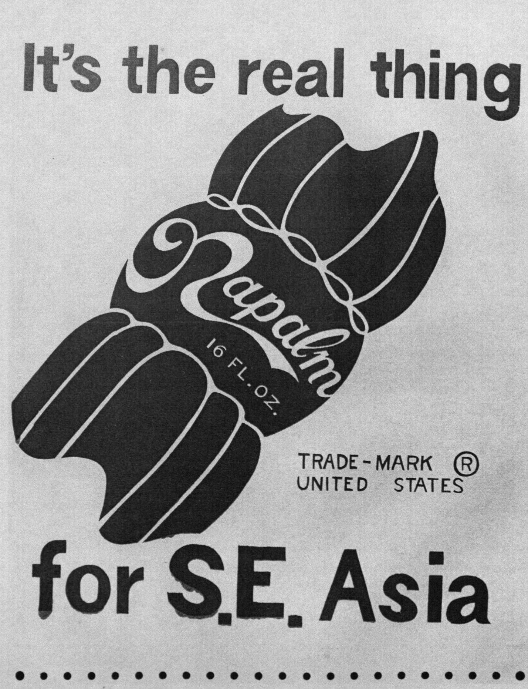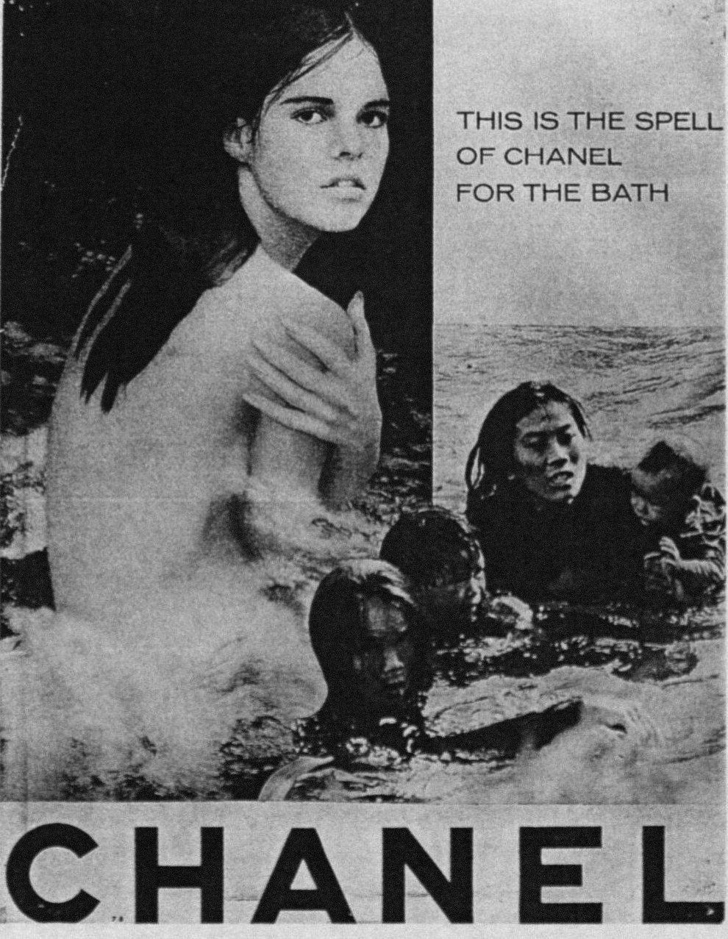

Posters criticized not only the atrocities of the war but the effects of the war on U.S. society. Lyndon Johnson had an ambitious plan to end poverty in the United States; he called it the “Great Society.” The plan had, as a focus, the creation of new social programs, the goals of which were to end poverty. But the increasing cost of the war eventually led to these social programs being cancelled. *Great Society* (Figure 23) is a poster that depicts the impact of the war at home. At the top, Johnson, with a sinister expression, is looking out. All of the images in the poster are engulfed in flames, images of people living in poverty, the ghetto riots, and American soldiers. A serious problem with continuing to wage the war which was also a serious domestic problem for the Nixon Administration was the continued deaths of American soldiers in an increasingly unpopular war. So Nixon tried to eliminate this problem with what he called Vietnamization (see Chapter 2). The poster (Figure 24) shows Nixon mounted on a B-52 airplane and holding a Nazi flag. The poster reads in four different languages: “Nixon’s Peace.”

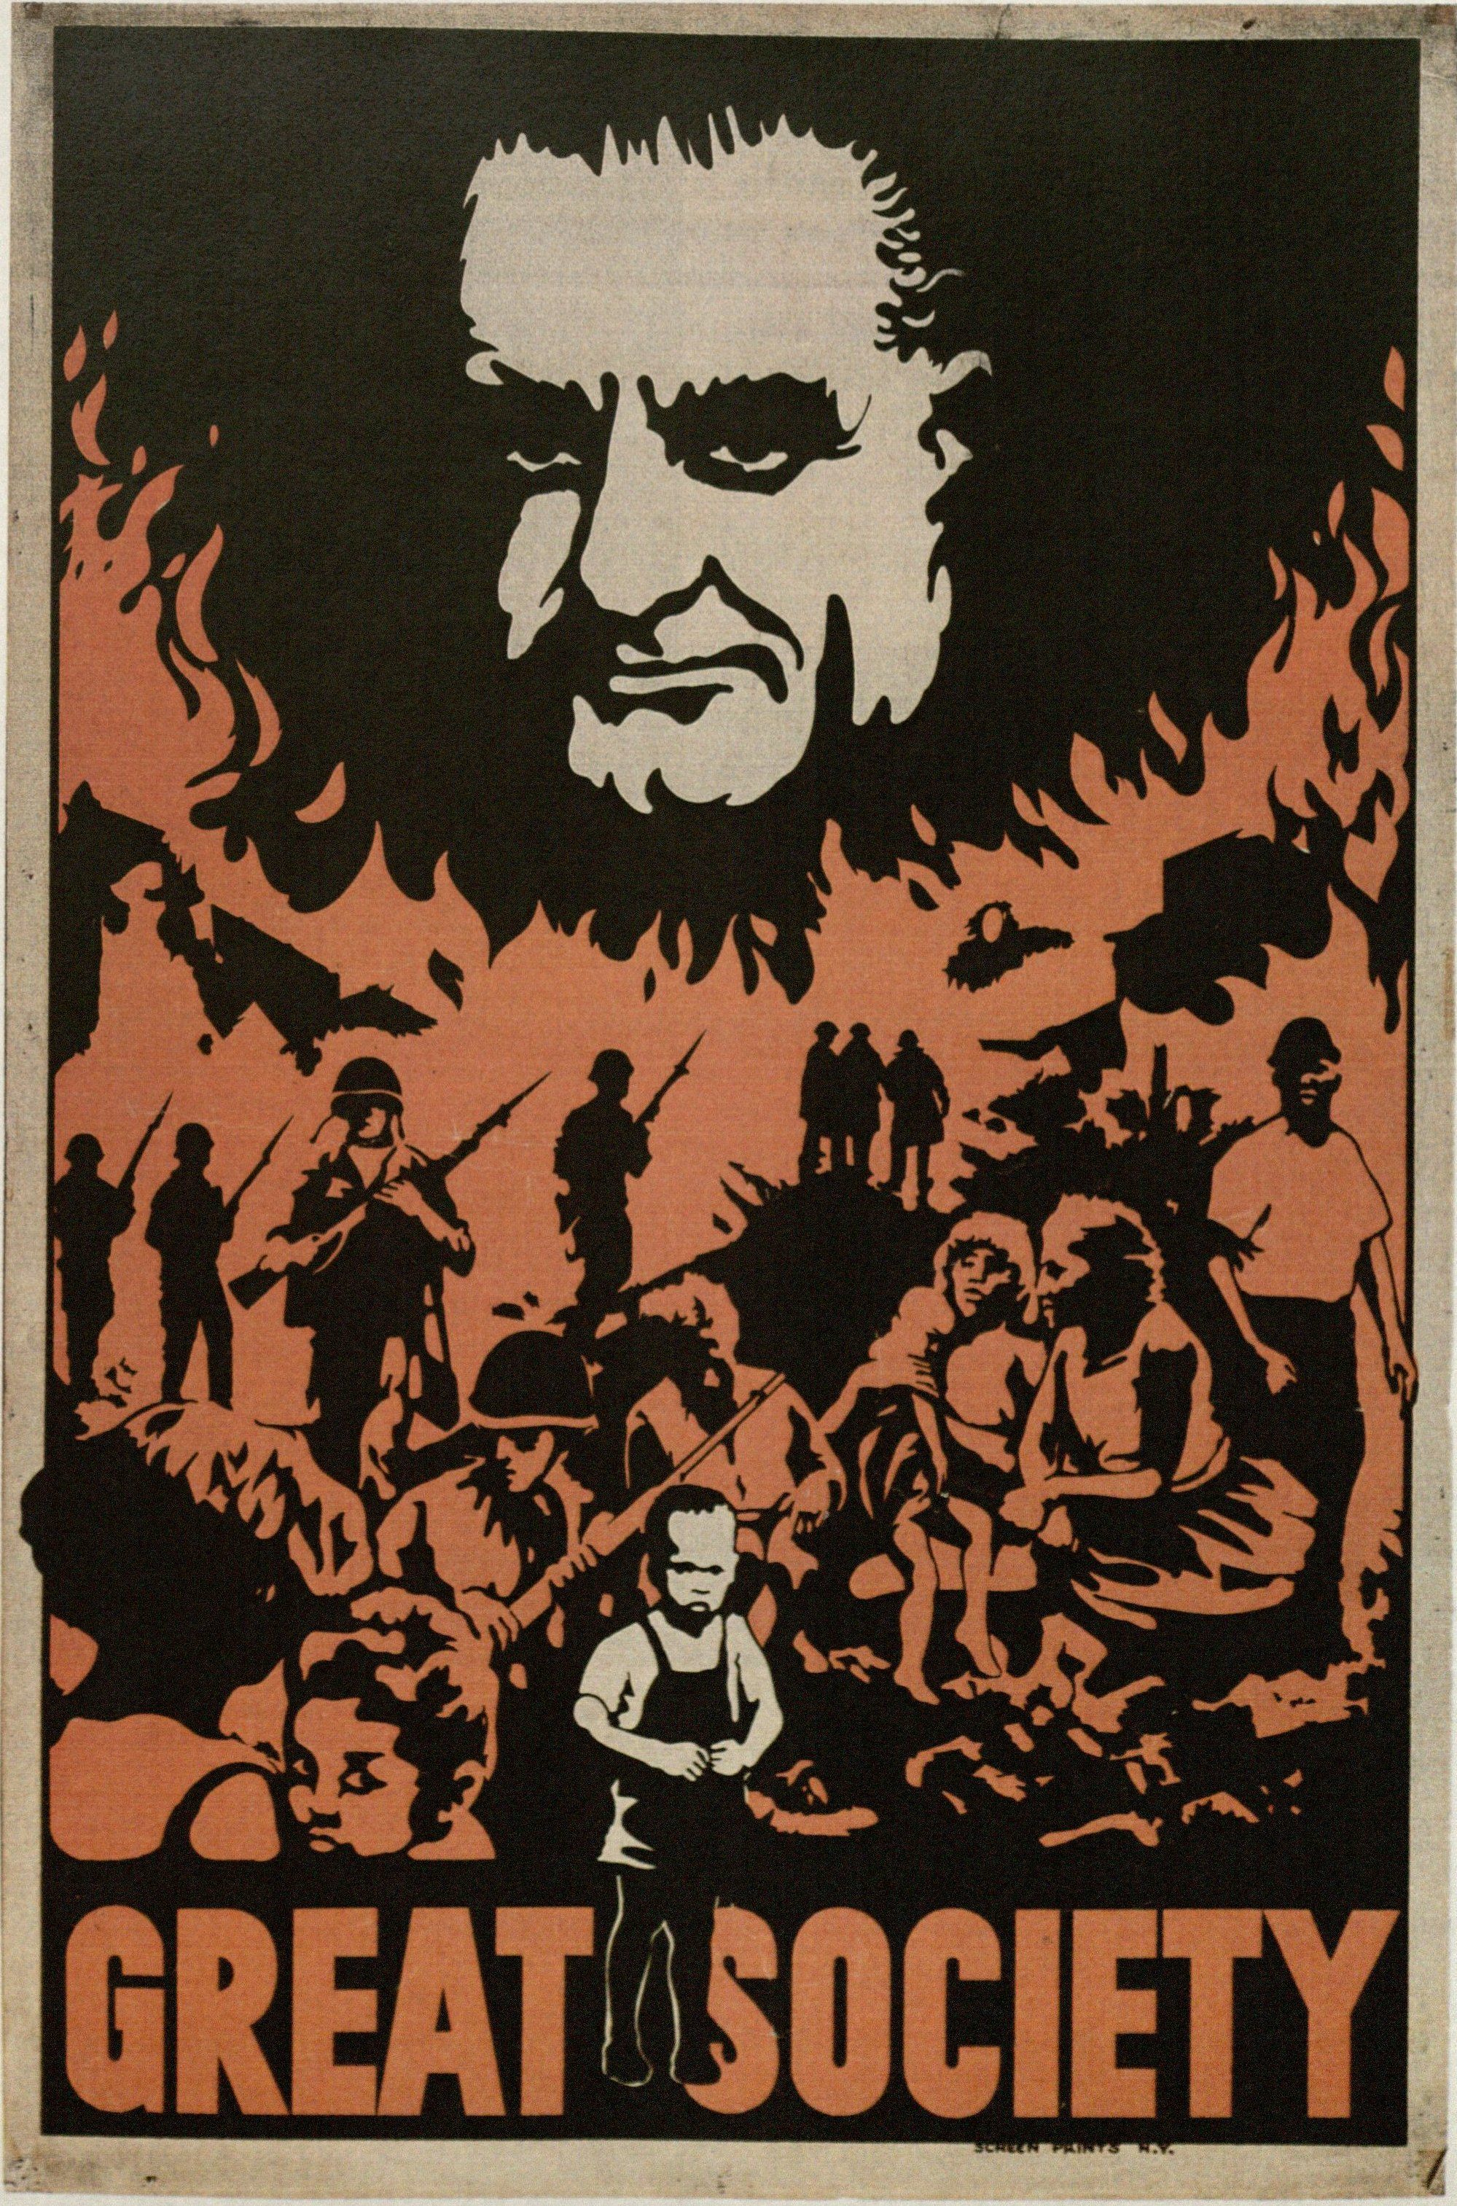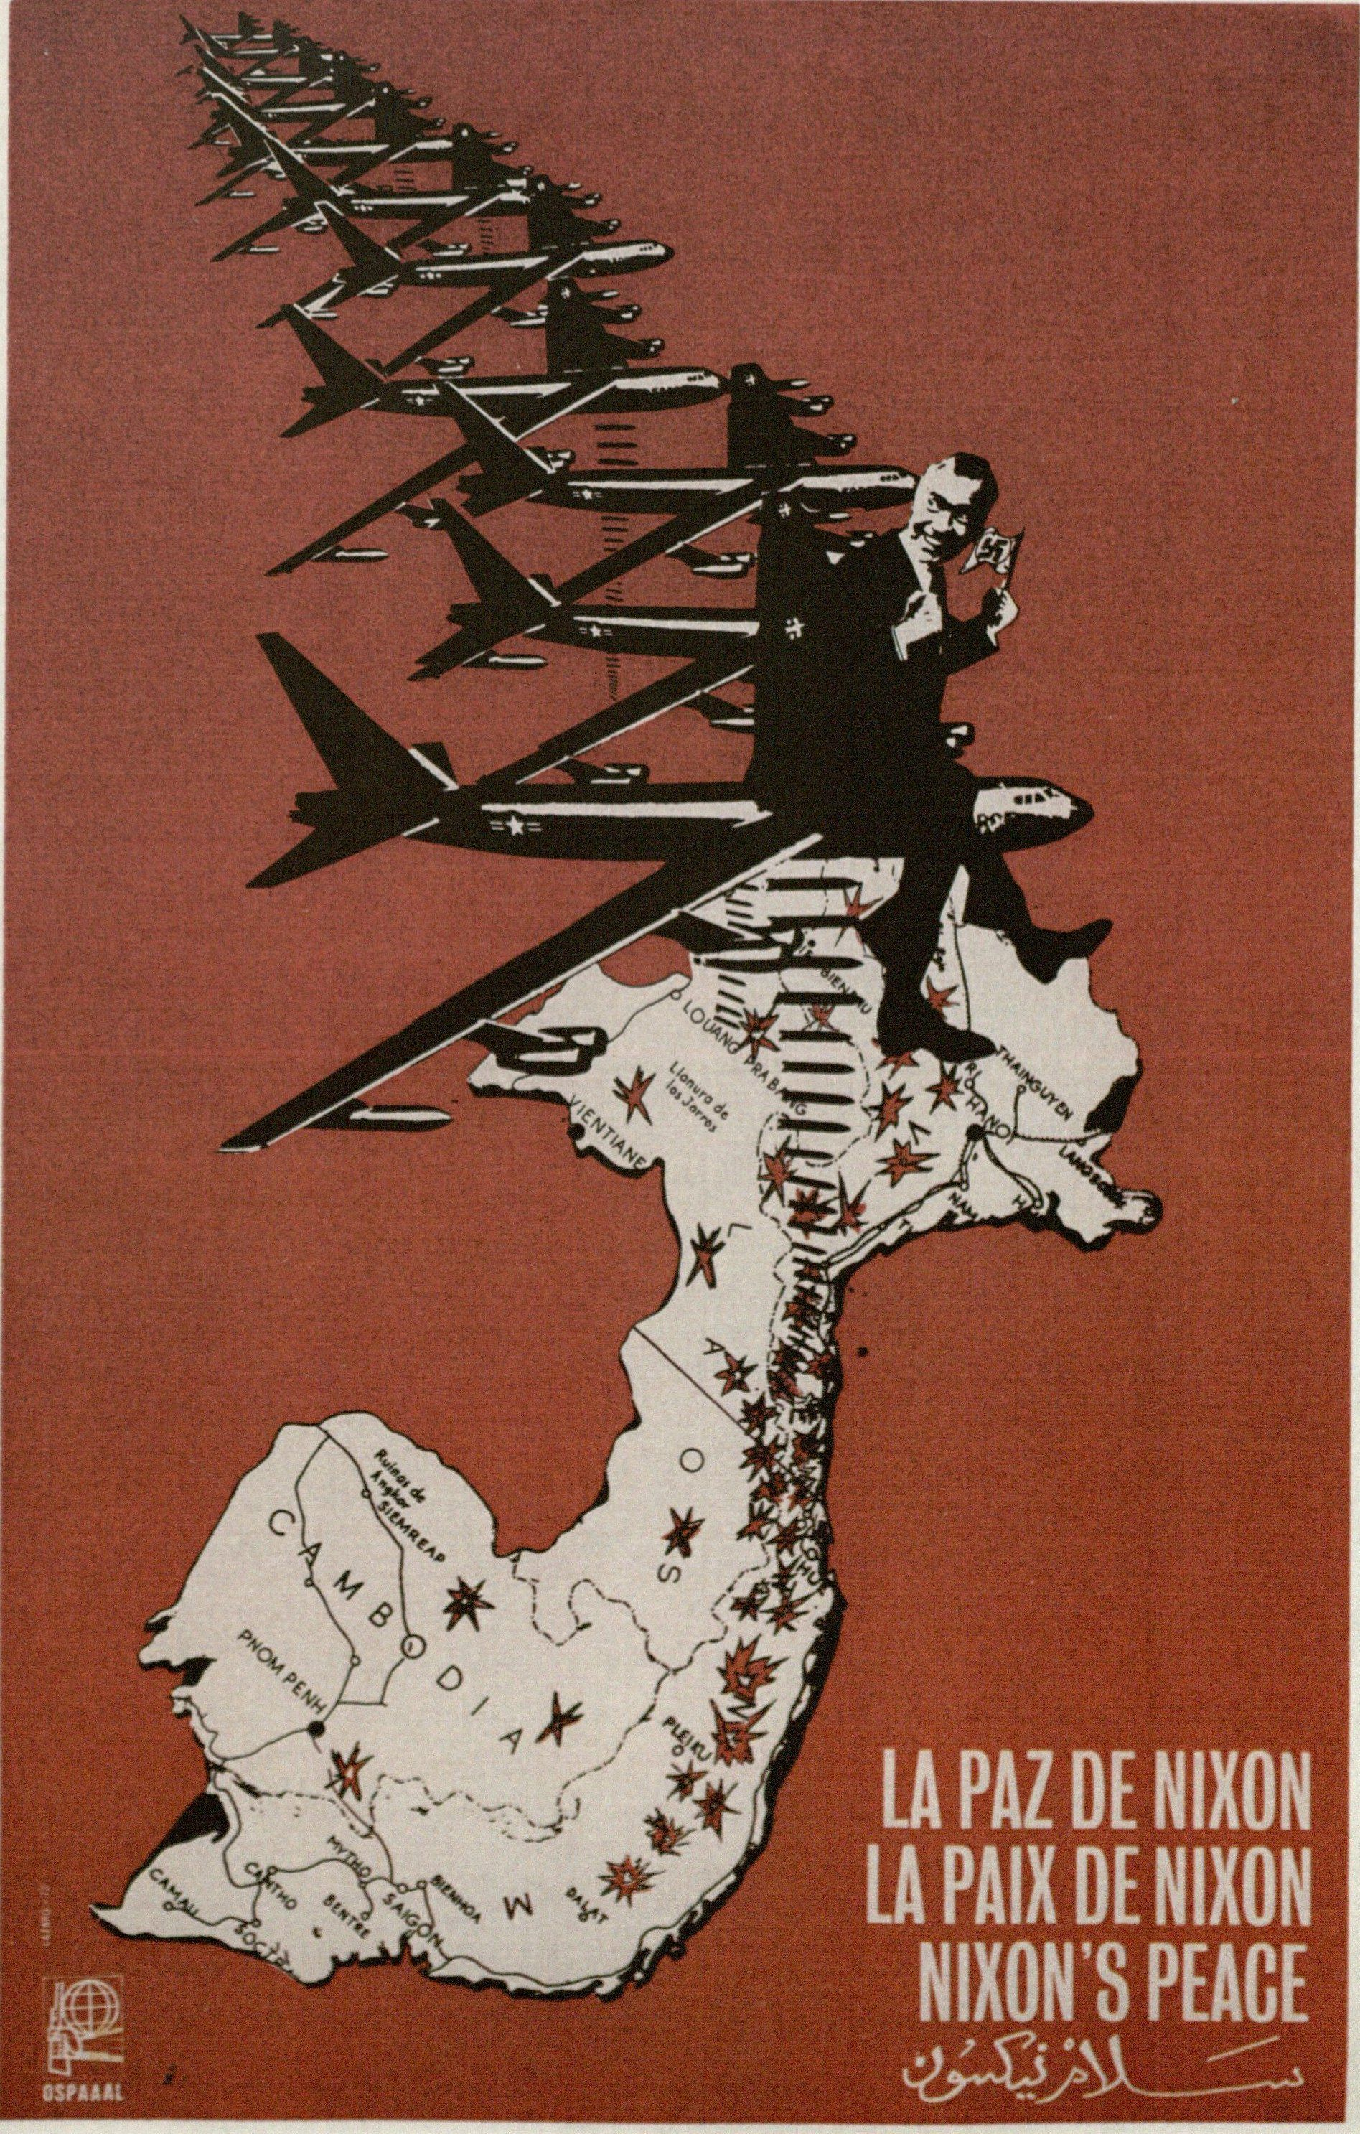

**Art and Atrocities**

Artists produced artwork that depicted the atrocities that were committed during the war by the American military. The use of war imagery in antiwar artwork became a powerful way to communicate to the American public the devastating effects of the American War on the Vietnamese people. An example (Figure 25) by an anonymous artist is a photograph of a child holding his arms out to a man who is burning him with a Zippo lighter. The poster reads, “Would you burn a child?” and the answer, on the bottom half of the poster reads, “When Necessary.” Below the text is a photograph of a Vietnamese woman holding a badly burned child?

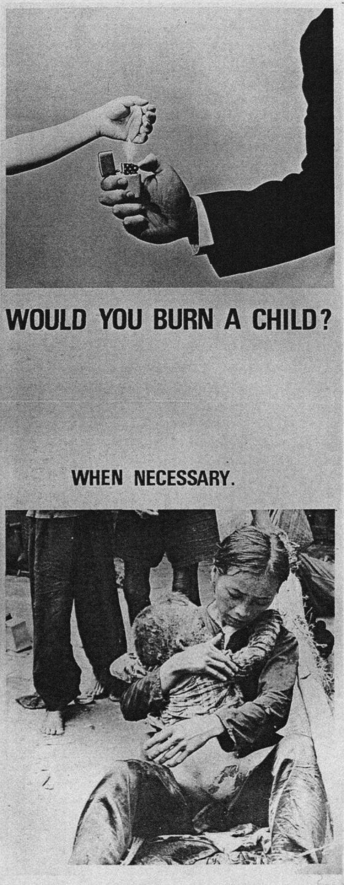

Women Strike for Peace,[18] a prominent pacifist group during the Anti-Vietnam War Movement, used posters protesting the use of napalm. And example (figure 26) is a poster that uses an excerpt from Martin Luther King Jr.’s *Beyond Vietnam* Speech. The text reads: “If America’s soul becomes poisoned, part of the autopsy must read Vietnam.”[19] The children shown in the poster are children burned by napalm. Michele Oka Doner, a Michigan University undergraduate art student, created a series called *Death Masks* (Figure 27)*.* The death masks were ceramic molds of a series of dolls and death masks with tattoos or mutilations. These were understood to be a reference to the victims of napalm.

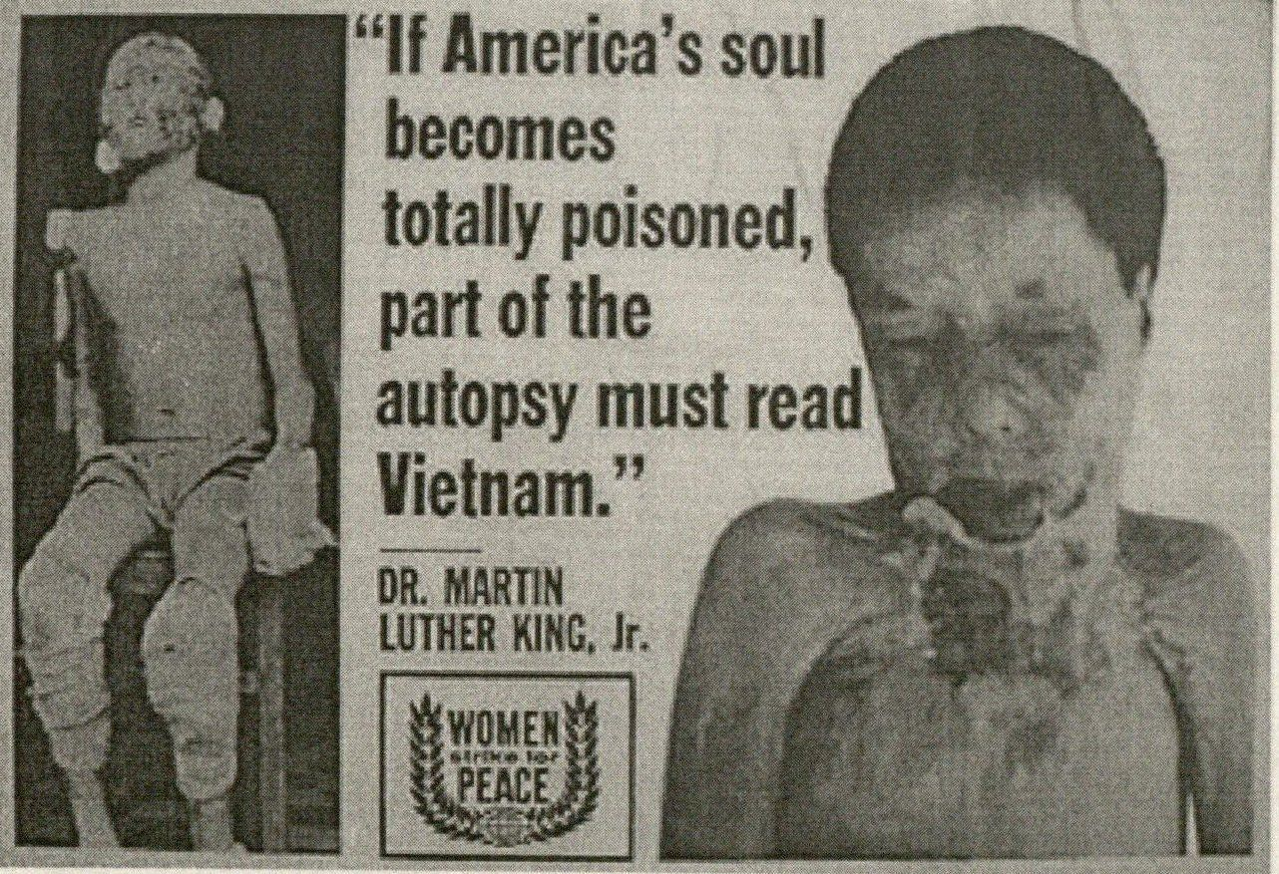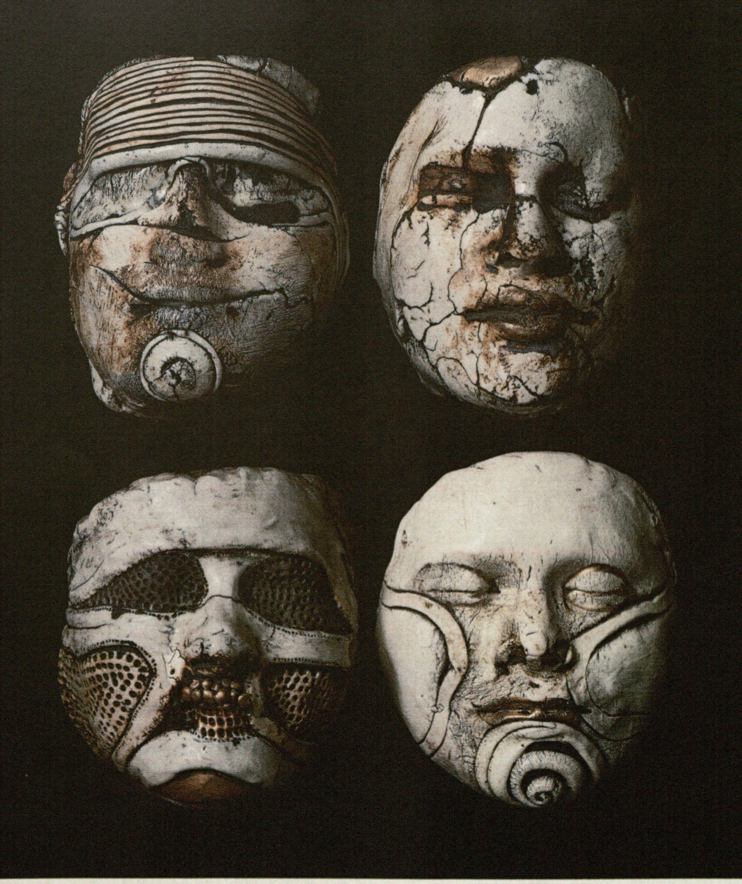

The United States dropped seven million tons of bombs during the war, amounting to three times the total of bombs dropped on Europe, Asia, and Africa during the Second World War (Karnow). Many artists produced work that depicted the bombing and its adverse affects on the Vietnamese population. Printmaker Antonio Frasconi created a book-object titled *Viet Nam!* Published in 1967, the book is a visual narrative of images taken from newspaper photographs of air strikes, pictures of bombing victims, and bomb sights. *Untitled* (Figure 29)is a woodprint of a black and white image with five rows of B-52s dropping bombs onto a landscape. Furthermore, to protest against the escalation of carpet bombing, many artists created posters. An example (Figure 30) shows an American eagle raining fire on a small village of peasants. The poster, by Doug Lawler, reads, “Bring the Monster Down, End the Air War.” In 1970, Robert Morris produced a series of lithographs called, “Five War Memorials.” *Crater with Smoke* (Figure 31) shows postwar craters under ominous skies. The landscape represents the devastating effects of bombing on people, their homes and villages and the environment. The American War had left twenty-one million bomb craters in Vietnam and destroyed twenty-five million acres of land (Zinn).

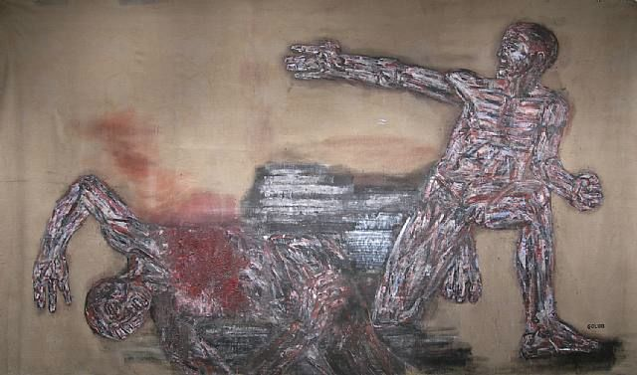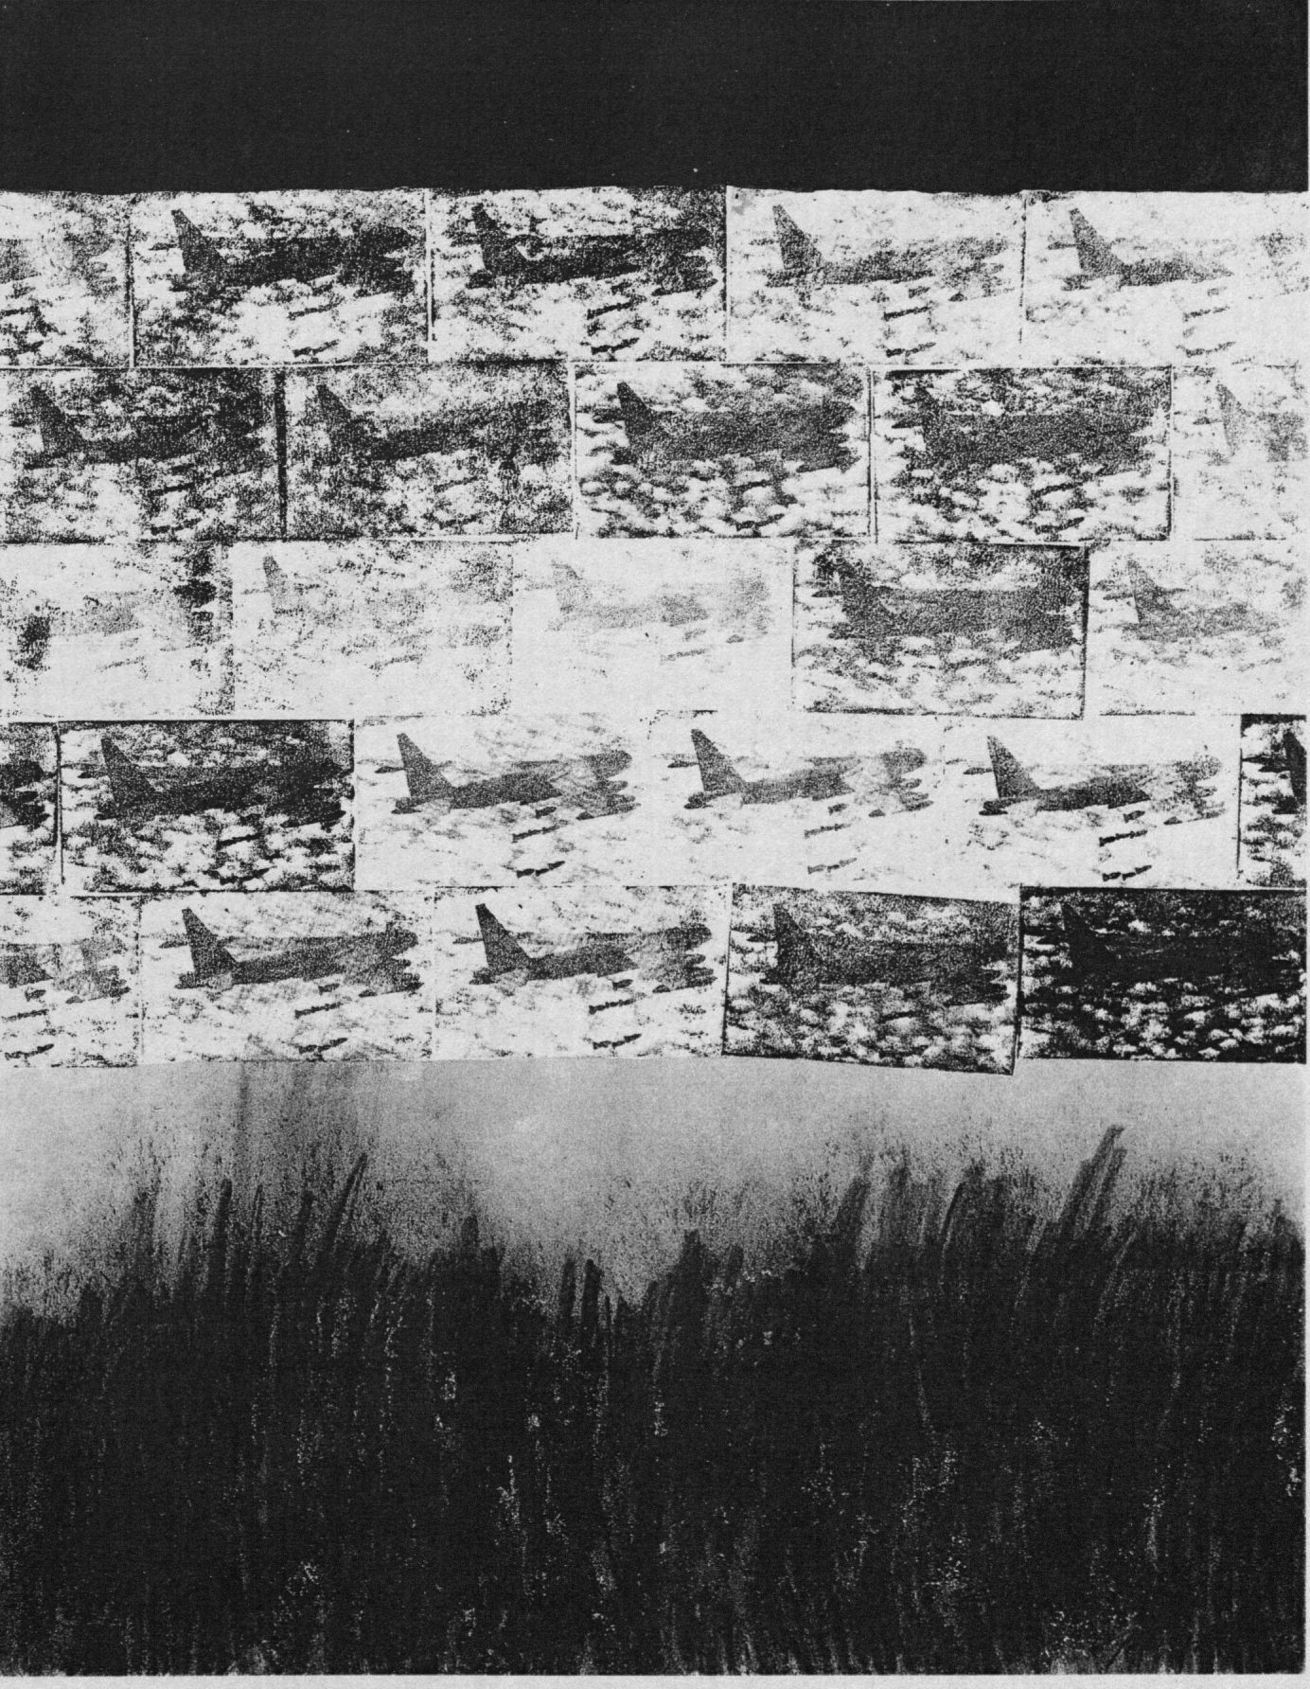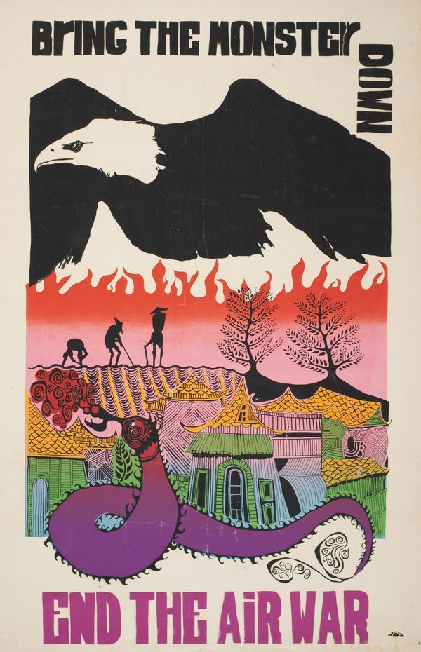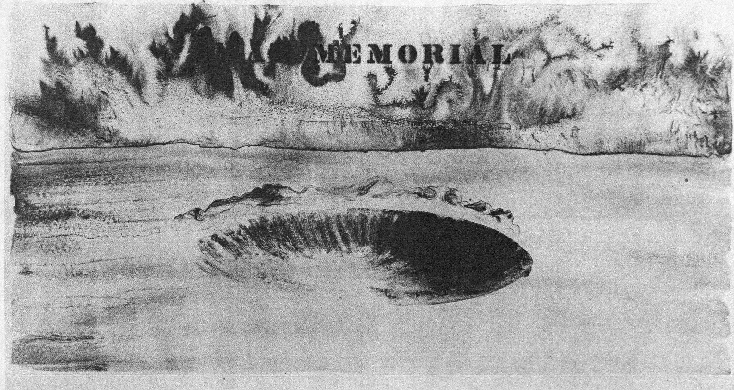

Art and the Military

Antiwar artwork even appeared in underground GI newspapers. An example is a drawing (Figure 32) that shows a maimed soldier, wearing a Purple Heart and bandage from head to toe, standing next to a little boy who is holding a toy automatic weapon and the American flag. The boy stands in front of a poster of a soldier that reads “The Army Builds Men.” The boy stares at the soldier with a confused expression. *Black Unity*, (Figure 33) appeared in an antiwar newspaper. It accompanied an article that was written by black soldiers stationed in Camp Pendleton which addressed racism in the military. The picture shows a black soldier beside a quote from Number Five (demanding all blacks be exempted from the war) of the Black Panther Party Ten-Point Program of Self-Defense.

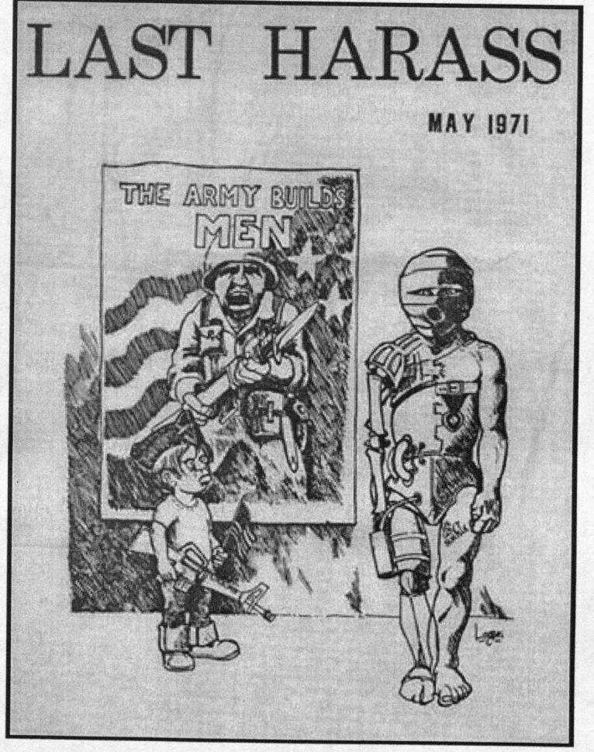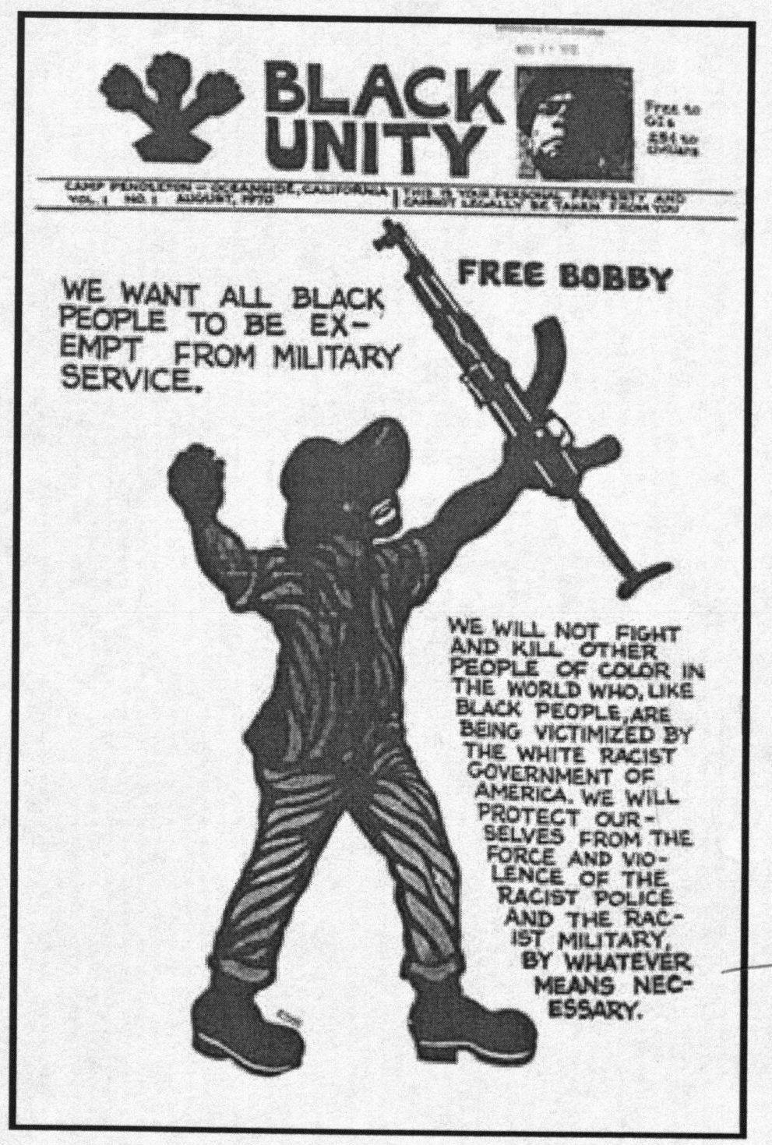

1. The 1947 House Un-American Activities Committee “Hollywood” hearings, created to uncover Communist subversion in the motion picture industry; thus, limited cultural expression during the Cold War. This, reinforced the view that art and culture should be separated from politics, the trend toward “apolitical art” also marked the visual arts, where abstract expressionism became the dominant form (Martin).
2. Hendrick continued to produce anti-war paintings during the 1960s and 1970s. In 1973, Hedrick’s whole “Vietnam” series was shown in San Francisco. The painting themselves were called “refugees,” “MIAs,” “war orphans,” or “wounded veterans” (Lippard).
3. April 18 and June 2, 1965.
4. AWC published its first letter in the *New York Times,* June 1962, protesting nuclear testing, requesting a test ban treaty, and calling for “tangible disarmament agreements.” The letter began, “We artists of the United Sates are divided in many ways, artistically, ideologically, but we are as one in our concern for humanity.”
5. Lippard and Martin
6. Designed by Mark di Suvero, and built by sculptor Mel Edwards and others (Lippard and Martin).
7. The elements of the event were ‘poets’ street caravans, midnight postering brigades,

   a conductorless performance of Beethoven’s Eroica at Town Hall (to symbolize the individual’s responsibility for the brutality of Vietnam). “Angry Arts Week” was the largest cultural protest event since the 40s (Lippard and Martin).
8. AWC resembled the Student Non-Violent Coordinating Committee’s efforts to function as a “leaderless” organization and the Living Theatre’s “collective creation.”
9. Spontaneous public performances or street theater to draw attention to a political or social issue.
10. In October 1968, GAGG removed Kasamir Malevich’s painting *White on White* from a gallery wall at MoMA and posted its list of demands in its place. GAGG chose Malevich piece because it once possessed “revolutionary” meaning but now was exhibited stripped of its political context and reduced to a “valuable object.”
11. See Appendix.
12. The creation of the poster was collaboration between GAAG members and the AWC poster committee.
13. Guernica is the ancestral lands of the Basque minority and had the population of seven thousand. The Basque opposed the authoritarian dictatorship of Francisco Franco who was backed by Fascist Italy and Nazi Germany.
14. During the summer, volunteer anti-war activists across the country knocked on doors and educated citizens about the human, moral, and economic costs of the war. In addition, legitimatized the illegality of the war.
15. Muhammad Ali, black boxer and heavyweight champion, refused to serve in what he called the “white man’s war” based on moral grounds. In 1966, he was denied CO deferment and refused to be inducted. He was stripped of his title and convicted of draft evasion. He told a reporter, “I ain’t got no quarrel with them Viet Cong, no Viet Cong ever called me nigger.”
16. The show opened at Judson Memorial Church on November 9, 1970.
17. The court suggested that visual art was not really a “form of communication” and was therefore not protected by the First Amendment.
18. The Women Strike for Peace played an important role in the anti-draft movement, counseling more than 100,000 young men (Hillstrom).
19. http://www.ratical.org/ratville/JFK/MLKapr67.pdf